Tacoma/Pierce County Habitat for Humanity
More than just an affordable home builder, Tacoma/Pierce County Habitat for Humanity provides Aging in Place critical home repairs for low-income senior homeowners and free-of-charge Housing Counseling services to help anyone in Pierce County prepare for homeownership or avoid foreclosure.
Tacoma Habitat sells homes under a restricted-resale model, ensuring the home remains permanently affordable to households earning under 80 percent of the area median income. Homebuyers purchasing now can expect a mortgage of about $1,600 per month for a 3 or 4BR home. With 120 units in the pipeline through 2027, Habitat is seeking qualified homebuyers who would benefit with a hand up into affordable homeownership.
Who do you know who qualifies for a Habitat for Humanity home?
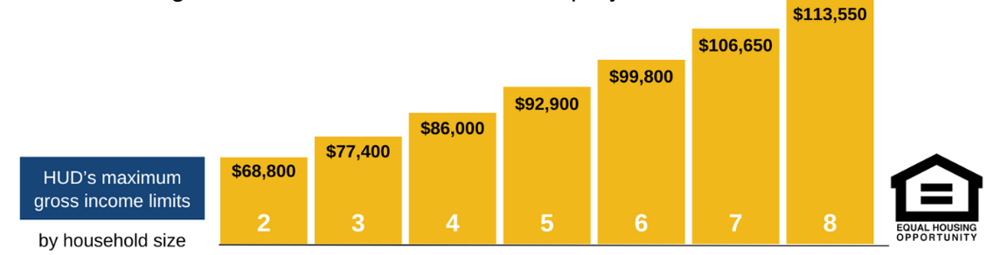
Join Transportation Club’s annual build days with Habitat
Transportation Club of Tacoma’s history of annual build days with Habitat for Humanity dates back to 2013. Club members and their families spend a day helping Habitat’s new construction operations and prepare a BBQ lunch to share with fellow volunteers, Habitat staff and homeowners.
Questions regarding Habitat’s programs or how to get involved as a volunteer? Contact Tracey Sorenson, Director of Community Engagement. 253-627-5626 x 104.

